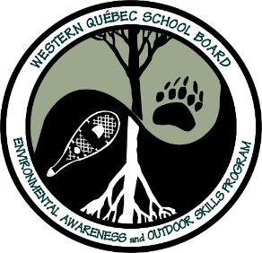
Nature Trivia Questions – Part 2
(Questions #11-20)
(Please note: Answer page can be found on a separate attachment)

#11- What ocean(s) surrounds Canada?
#12- What is the largest living animal in the world?
#13- What is the largest carnivore in the world that lives on land?
#14- Which of the turtles below lays their eggs in the water?
- Snapping turtle
- Painted turtle
- Map turtle
- None of the above
#15- How do snakes smell?
#16- Which of the following animals hibernate during the winter?
- Black Bears
- Chipmunks
- Raccoons
- All of the above
#17- What is the fastest bird in the world?
#18- Which mosquito bites animals?
- Female mosquitos
- Male mosquitos
- Both female and male will bite
#19- What statements below about bees is true in how they can help flowers and plants?
- Bees will defend and sting predators that are trying to pick the flowers or fruit.
- Bees will carry and spread the seeds of plants in order to help them reproduce.
- Bees eat spiders and caterpillars which can be harmful to flowers and plants.
- All of the above
- None of the above
#20- Are lady bugs in Canada helpful or harmful to humans?

