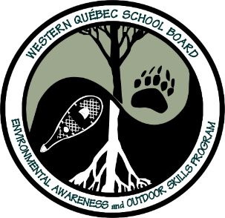
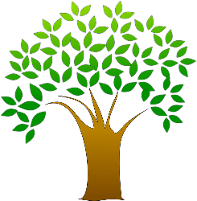
Nature Trivia Questions – Part 1
(Questions #1-10)
(Please note: Answer page can be found on a separate attachment)

#1- Which bird is the worst walker on land?
- The Snowy Owl
- The Canada Goose
- The Loon
#2- Which animal relies heavily on acorns for food in the fall?
- Black Bears
- White Tail Deer
- Squirrels
#3- What living thing migrates over the winter in Mexico travelling up to 4000 kilometers to reach its final destination?
#4- Why do Monarch Butterflies depend on the Milkweed plant for their survival?
#5- What is the Aurora Borealis and how is it created?
#6- What animal has the official status as a symbol or emblem of Canada?
#7- What is the national tree of Canada?
#8- What is Canada’s national bird?
#9- What is Quebec’s provincial bird?
#10- When is Earth Day in Canada?

