**Nature Scavenger Hunt – Part 1**

**5 Senses Challenge**

****(Check each item off as you find it )**

Sight 

 - Bird

 - worm

 - Squirrel

 - Flower

 - Colors -green/brown/white/pink

Other sights ________________

Sound 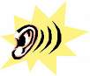

 - Birds

 - Wind

 - Water moving

 - Leaves crunching

 - Animal sounds

 Other sounds ___________________

Touch 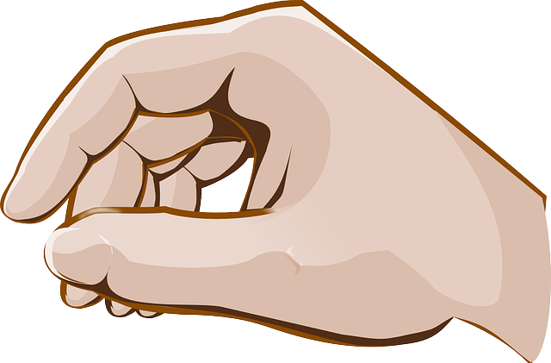

 - Rocks

 - Mud

 - Water

 - Something green

 - Something soft

 - Something prickly

 - Something smooth

 - Something else _________________

Taste 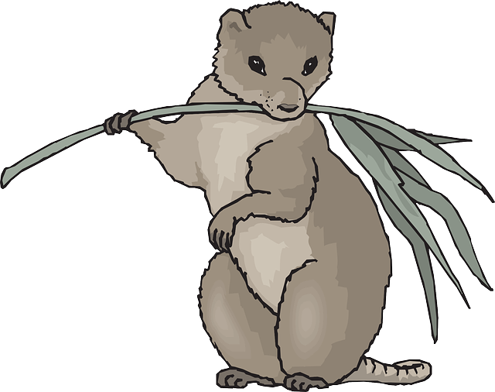

 - Something an animal would eat

 -Something humans could eat



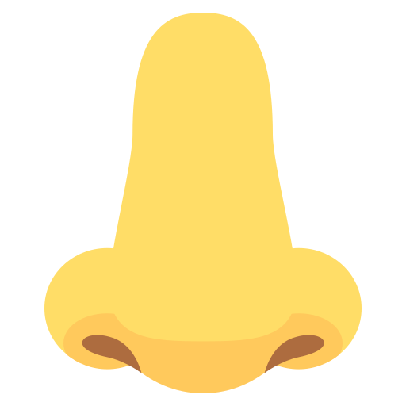Smell

 - Trees/ leaves/pine needles

 - A smell you like

 - Fresh air

 - Earth/dirt/mud

 Other smells ___________________