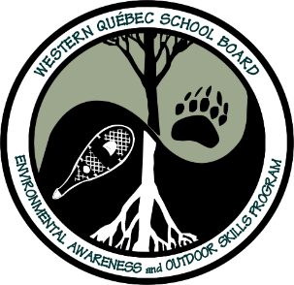
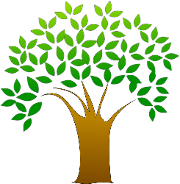
The Nature Art Gallery

Objective- To appreciate and find the beauty in nature that surrounds us by creating an art piece with simple items from the natural environment. Participants will use imagination and creativity to make a mini display of natural objects that capture something interesting and beautiful that could be presented in a “Nature Art Gallery”. Displays can also include items to show the positive role that they serve to help nature or other living things. For example, a simple leaf or branch can be found beautiful for the colors, shapes, bark and vein patterns, but also, leaves and branches helps nature by making oxygen, shelter for bird nests/insects, and food for animals etc….
Materials- objects from nature, something flat to place items on (shoe box, pie plate, piece of wood, card board, wax paper… etc.), cue card or lined paper.
Method-
- Go outside and look for interesting and special objects from Nature that catch your attention. The list of types of objects that you could find is huge: rocks, sticks, bark, branches, feathers, leaves, moss, dead bugs. seeds, dried flowers, etc… Examine items for their uniqueness of artistic patterns, colors, texture, and shape, etc… Collect as many different items as you can. You may also look for signs of how an object was helpful in nature. For example, a branch with a maze of insect tunnels is artistic but also the branch was a home and food for a family of bugs.

- In order to create a collage or diorama, place the nature objects on a flat surface such as a shoe box, pie plate, piece of wood, wax paper… etc.

- With your imagination and creativity develop an art piece with your favorite objects that could be placed in a “Nature Art Gallery”. Arrange them in your own special way to create a design or to tell a story. The chosen display objects could also focus on the purpose they have in nature.

- Write a mini description of your nature art on a cue card or lined paper that will be placed along with the display. There are no limits to what you can write about. It could be a poem, a fictional story, or even a description of why you like these objects and what they mean to you. It could also be a simple reflection of a personal experience that the object helps you to remember. You can also describe the objects from an ecological point of view of how the objects are beneficial and helpful to other living things.

- The Nature Art Gallery is now ready to open. Put your art piece and cue card on display. Share with others!

